Operational Notes

# 1. Hardware

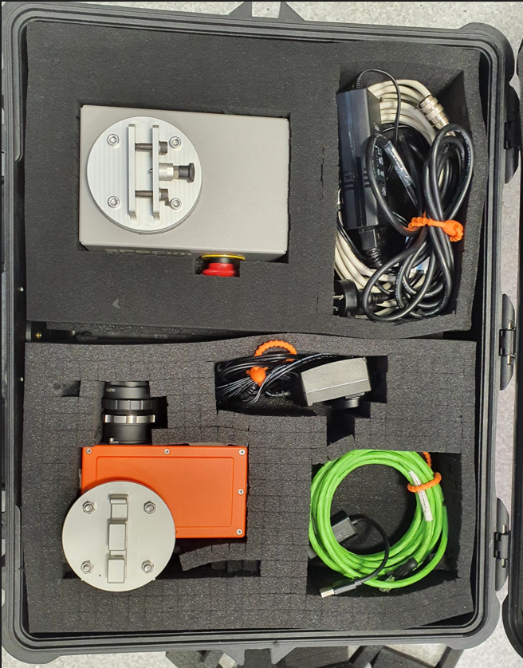

2. Rotary Stage

5. FX17 Camera

3. Camera Comm

1. Rotary cables

4. Camera Power

**\*Note: make sure to bring the tripod and halogen lights**

1. SPECM FX17

* The POWER12VDC connects with Camera Adapter.
* Camera Comm (green wire) connects with GigE at the SPECM FX17 and connects with ThinkPad laptop (at the right hole).

2. SPECM RS10 – Rotary Stage

* The Power cable and RS232 cable connects with Rotary Stage Comm wire which is connected to the right 3rd USB pin (bottom pin) on ThinkPad laptop.

3. ThinkPad laptop

* The ThinkPad laptop (on the left) connects with ThinkPad Split cable (7th pin) from the right.
* Right side of laptop connects with mouse and keyboard.

From the docking station: ThinkPad USB MAC (USB pins connector)

* 1st (from left of ThinkPad) USB pin (UNITEX USB cable) connects with Camera Comm (green wire).
* 2nd USB pin leaves.
* 3rd (from left of ThinkPad) USB pin (bottom one) (silver cable) connects to Rotary Stage Comm which has Rotary Stage Adapter that is connected to Rotary Stage Power.
* 4th (from left of ThinkPad) bottom pin connects to right PC and upper pin connects to middle PC.
* 5th and 6th USB pins just leave.
* 7th USB pin (Thinkpad split cable) connects to Thinkpad laptop left side of USB pin which is next to the light. Laptop side has the USB header which is written ThinkPad on it.
* 7th USB pin connects with Lenovo AC adapter.

Lenovo AC Adaptor

* Lenovo AC Adaptor (using LONGWELL CABLE) connects with ThinkPad’s the last pin (8th).
* GFC-3R connects to Lenovo AC adapter’s left side (rectangle shape header).
* GFC-3R's small header connects to the right side of the Lenovo AC Adapter.

4. Complete List of Components

|  |  |
| --- | --- |
| 1. Camera | 9. Silver USB cable |
| 2. Camera Comm (green cable) | 10. 2 USB cables for 2 PCs |
| 3. Camera Adapter | 11. Thinkpad Split cable 0.7M |
| 4. Rotary Stage Comm | 12. LONGWELL Cable with has 3 USB headers |
| 5. Rotary Stage Adapter | 13. ThinkPad USB MAC |
| 6. Rotary Stage Power | 14. Lenovo AC Adaptor |
| 7. Rotary Stage | 15. Tripod |
| 8. UNITEX cable | 16. Light |

# 2. Image Acquisition

This is a short note to produce image data cubes using FX17e camera with rotational stage.

This FX17e camera has a push-broom mode and gathers hyperspectral data in the near-infrared NIR (900 – 1700 nm) region. It has the standard lens which is OLET17.5 with 38 degrees FOV and the focusing distance of it is 150 mm. The spectral camera is attached to a Rotary Stage 10 scanner which can be controlled for scanning speed and angle with the SPECIM Lumo Scanner data acquisition software. The maximum scanning angle of the scanner is 180 degrees.

**Initial Setup**

After launching Lumo software, the program opens the **Setup** screen. This screen allows for the connection of the camera and rotary stage. After clicking on the **Connect** tab in **Sensor1**, **Device Selection** will come out and it needs to select the corresponding IP address and click on **OK**. In the capture folder, it can set up the pointer to directories for image storage.

* In **Devices sensor 1 section**, select **FX17 e with Pleora** and press **Connect**. In the Sensor 1 section, you can also set up the **Capture folder**. This leads to the address of the folder where all the recorded images will be subsequently stored.
* In **Motor 1**, **Channels** should be set to **COM6,** and **Profile** is set to **Rotary 10** and click on **Connect**. This sets up the serial connection to the rotary stage. If it fails to detect the motor, check the power supply is on and **emergency stop** is open on the rotary unit and then press **Detect** on the motor 1 panel and then **Connect**.

The camera and rotary stage are now fully connected and ready for operation.

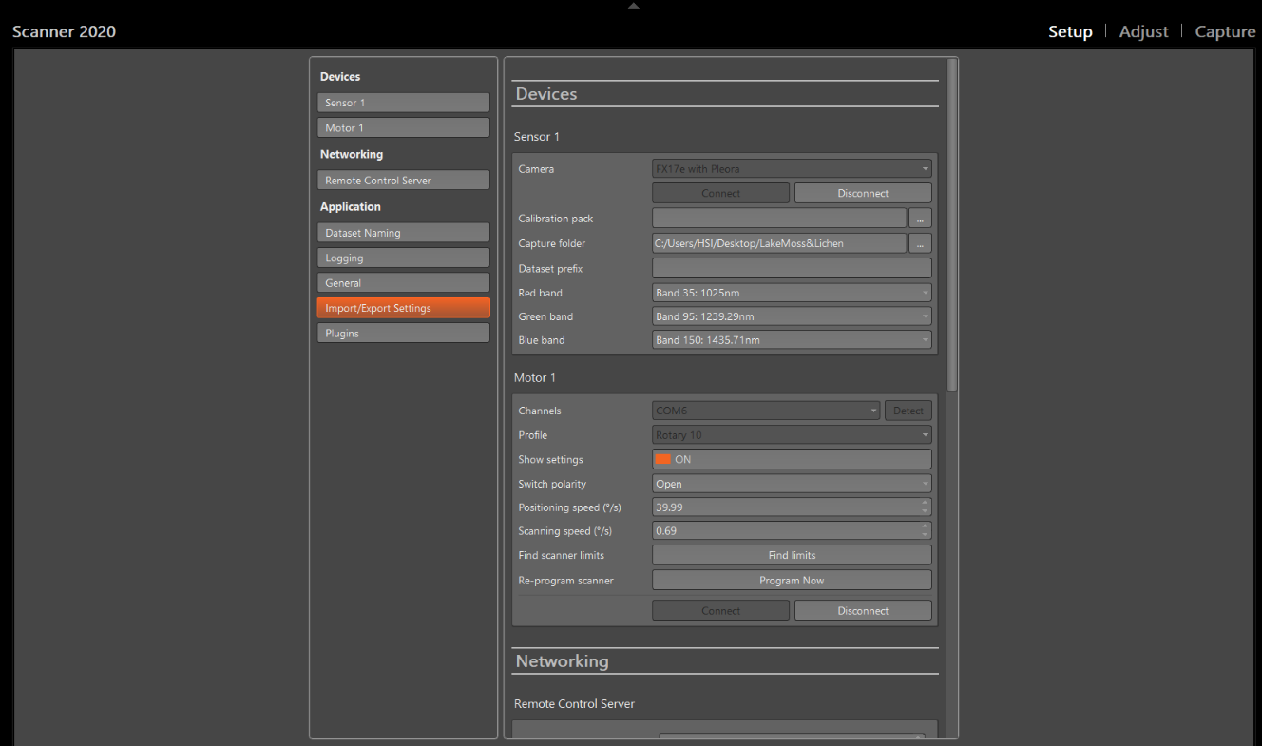

Figure 1 LUMO Scanner Setup

**Camera Setup**

In this section, to acquire the image, the operation for the camera and scanner are set as the following order

* Set scan area
* Set camera focus
* Set RGB locations
* Set scanning speed
* Set image correction
* Set exposure time and lighting

**Scan Area**

In the Sensor 1 positions tab, select a target start and target stop locations and ensure that you select Set after changing the position. Both the sensor and waterfall panels are useful in locating where you are in the scene as you adjust these parameters.

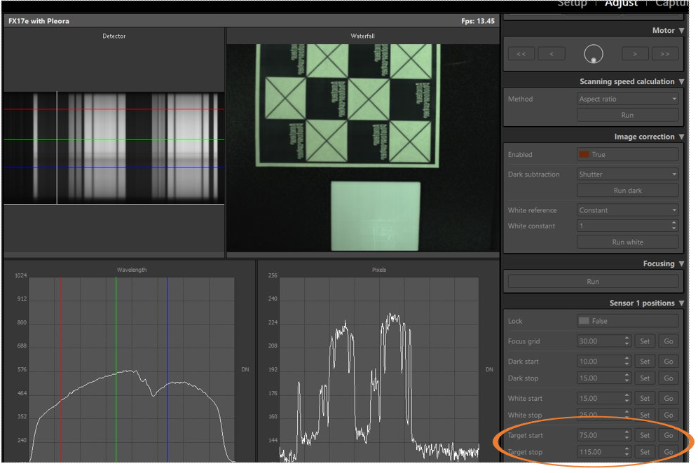

**Focus**

Drive the camera to the middle of your scene using the **Motor** controls tab. Here having placed a focusing grid on the tray press **Run** on the **Focusing** window. Note this does not perform focusing but merely indicates how well the image is focused. Focusing is achieved by adjusting the lens focusing ring while observing the straight edges on the focusing grid on the **detector** window. When these lines appear sharp and the focusing window shows green then the camera is focused.

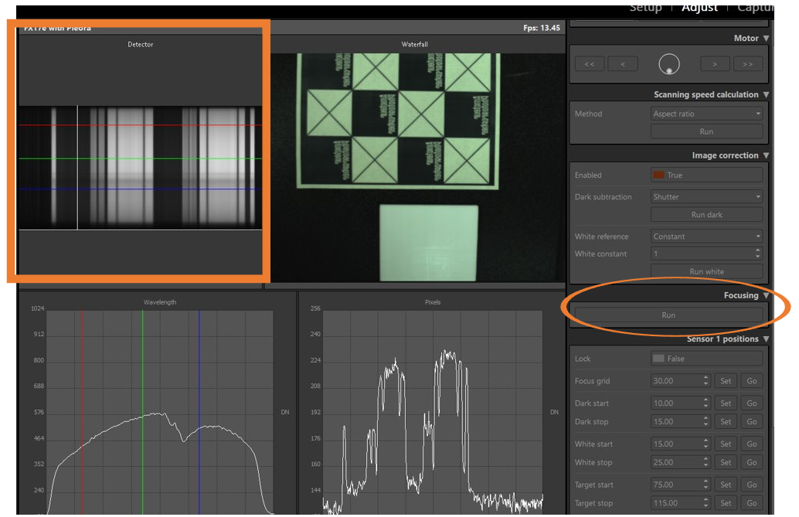

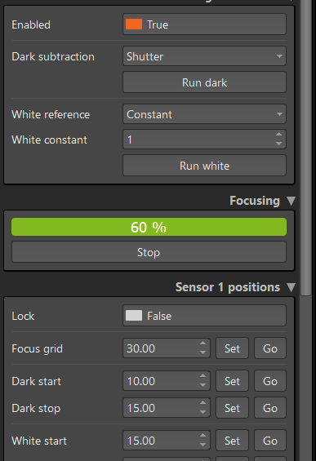

**RGB**

In the **Wavelength** window, using the mouse drags the red, green, and blue lines from the default position of 900nm to areas within the sensitive portion of the wavelength response. These are used for the pseudo-color image produced and the waterfall window.

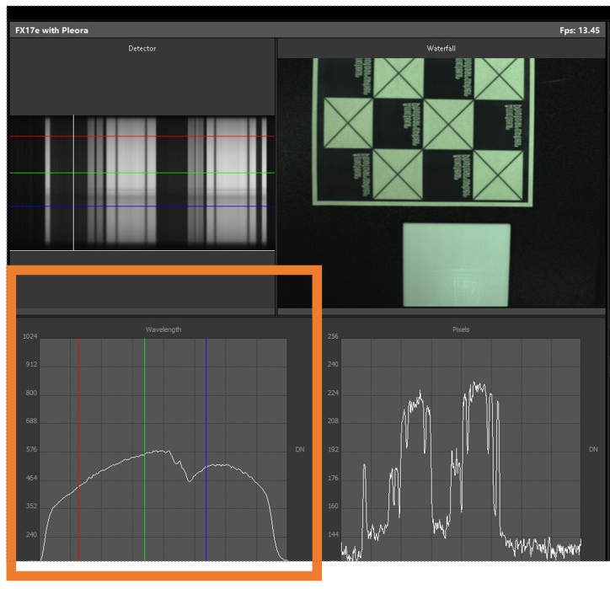

**Sanning Speed Calculation**

This is achieved by the **Scanning speed calculation** window. Select **Method** as **Aspect ratio** and then **Run**. This takes about 30 seconds for the calculation to be performed and upon completion prompts for a change to the scanner, camera or manual. However, in some cases, **manual** or **field of view** method can be used and adjust the corresponding **scanning speed** or d**egree of field of view** to obtain the suitable scanning speed calculation. Once the appropriate scanning speed is obtained, it can set up back to the **Aspect ratio**.

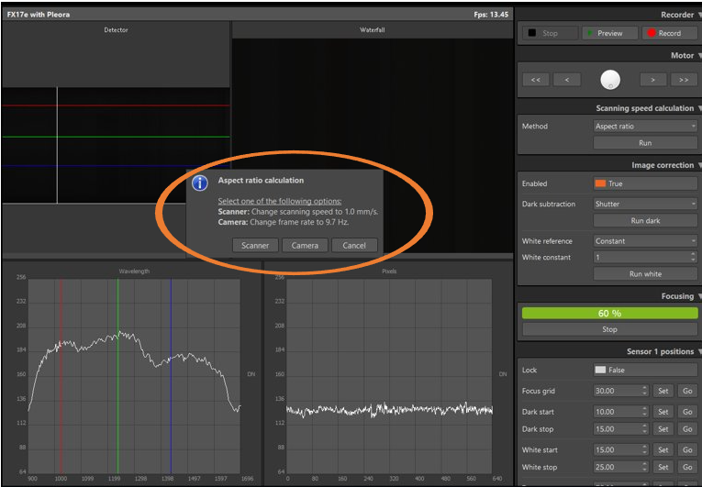

**Image Correction**

The Image correction window provides the necessary data to correct for camera and lighting variations in the image and should be set up the image below.

**Exposure time**

This setting sets the brightness of the image. Increasing the exposure time essentially gathers more light and brightness of the image. However, the trade-off is that the scanning time and the risk of saturation of the sensor is increased.

Another way is that we can achieve this by moving the halogen light source closer to the image while observing the waterfall image. This can lead to an increase in the brightness of the image. Adjusting the place of halogen light source also plays an important role in capturing the sharp image.

**Image Acquisition**

The system is now ready to acquire images by selecting the **Capture** screen. It is recommended to perform a preview of the image to assess if any further areas of detector saturation (show as Red) occur in a significant portion of the image. This could be due to specular reflection from objects in the image. If so, further adjustments of exposure time or placing halogen light source are required. Once happy with the preview, name the image in the **Dataset name** which will be appended with the timestamp and press **Record**.

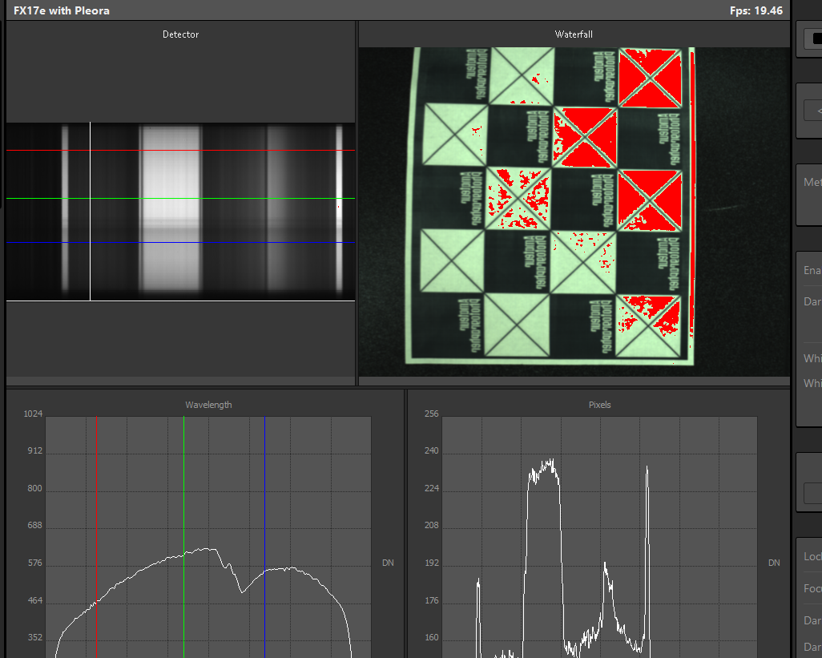

A **traffic lights** system in the bottom right side of the screen also indicates the quality of the image produced.

The raw data will be now saved along with the dark current data to a new directory under the **Capture** folder previously selected.

# 3. Header files

**ENVI Header File**

|  |  |
| --- | --- |
| Header keyword | Description |
| File description | |
| ENVI |  |
| description | File Imported into ENVI |
| file type | ENVI |
| AISA sensor description | |
| sensor type | FX17e, Lumo – Scanner v2020-586 |
| sensorid | 123456789 |
| GNSS/IMU information | |
| acquisition date | 2023-11-08 |
| GPS Start Time |  |
| GPS Stop Time |  |
| GPS Starting point |  |
| GPS Ending point |  |
| NavSync Timing = {XXXX, YYYY} |  |
| NavSync Extra |  |
| Data acquisition information | |
| fps | 10.21 |
| tint | 6.000000 |
| tint1 |  |
| tint2 |  |
| temperature | 48.58 |
| binning = {X, Y} | {1, 1} |
| qpfTiming = {XXXX, YYYY} |  |
| errors | {none} |
| Spectral band information | |
| default bands = {R, G, B} |  |
| wavelength | {900.00,903.57,907.14,910.71,914.29,917.86,921.43,925.00,928.57,932.14,935.71,939.29, 942.86,946.43,950.00,953.57,957.14,960.71, 964.29,967.86,971.43,975.00,978.57,982.14, 985.71,989.29,992.86,996.43,1000.00, 1003.57,1007.14,1010.71,1014.29,1017.86, 1021.43,1025.00,1028.57,1032.14,1035.71,  1039.29,1042.86,1046.43,1050.00,1053.57,  1057.14,1060.71,1064.29,1067.86,1071.43,  1075.00,1078.57,1082.14,1085.71,1089.29,  1092.86,1096.43,1100.00,1103.57,1107.14,  1110.71,1114.29,1117.86,1121.43,1125.00,  1128.57,1132.14,1135.71,1139.29,1142.86,  1146.43,1150.00,1153.57,1157.14,1160.71,  1164.29,1167.86,1171.43,1175.00,1178.57,  1182.14,1185.71,1189.29,1192.86,1196.43,  1200.00,1203.57,1207.14,1210.71,1214.29,  1217.86,1221.43,1225.00,1228.57,1232.14,  1235.71,1239.29,1242.86,1246.43,1250.00,  1253.57,1257.14,1260.71,1264.29,1267.86,  1271.43,1275.00,1278.57,1282.14,1285.71,  1289.29,1292.86,1296.43,1300.00,1303.57,  1307.14,1310.71,1314.29,1317.86,1321.43,  1325.00,1328.57,1332.14,1335.71,1339.29,  1342.86,1346.43,1350.00,1353.57,1357.14,  1360.71,1364.29,1367.86,1371.43,1375.00,  1378.57,1382.14,1385.71,1389.29,1392.86,  1396.43,1400.00,1403.57,1407.14,1410.71,  1414.29,1417.86,1421.43,1425.00,1428.57,  1432.14,1435.71,1439.29,1442.86,1446.43,  1450.00,1453.57,1457.14,1460.71,1464.29,  1467.86,1471.43,1475.00,1478.57,1482.14,  1485.71,1489.29,1492.86,1496.43,1500.00,  1503.57,1507.14,1510.71,1514.29,1517.86,  1521.43,1525.00,1528.57,1532.14,1535.71,  1539.29,1542.86,1546.43,1550.00,1553.57,  1557.14,1560.71,1564.29,1567.86,1571.43,  1575.00,1578.57,1582.14,1585.71,1589.29,  1592.86,1596.43,1600.00,1603.57,1607.14,  1610.71,1614.29,1617.86,1621.43,1625.00,  1628.57,1632.14,1635.71,1639.29,1642.86,  1646.43,1650.00,1653.57,1657.14,1660.71,  1664.29,1667.86,1671.43,1675.00,1678.57,  1682.14,1685.71,1689.29,1692.86,1696.43  } |
| fwhm | {  900.00,903.57,907.14,910.71,914.29,917.86,  921.43,925.00,928.57,932.14,935.71,939.29,  942.86,946.43,950.00,953.57,957.14,960.71,  964.29,967.86,971.43,975.00,978.57,982.14,  985.71,989.29,992.86,996.43,1000.00,  1003.57,1007.14,1010.71,1014.29,1017.86,  1021.43,1025.00,1028.57,1032.14,1035.71,  1039.29,1042.86,1046.43,1050.00,1053.57,  1057.14,1060.71,1064.29,1067.86,1071.43,  1075.00,1078.57,1082.14,1085.71,1089.29,  1092.86,1096.43,1100.00,1103.57,1107.14,  1110.71,1114.29,1117.86,1121.43,1125.00,  1128.57,1132.14,1135.71,1139.29,1142.86,  1146.43,1150.00,1153.57,1157.14,1160.71,  1164.29,1167.86,1171.43,1175.00,1178.57,  1182.14,1185.71,1189.29,1192.86,1196.43,  1200.00,1203.57,1207.14,1210.71,1214.29,  1217.86,1221.43,1225.00,1228.57,1232.14,  1235.71,1239.29,1242.86,1246.43,1250.00,  1253.57,1257.14,1260.71,1264.29,1267.86,  1271.43,1275.00,1278.57,1282.14,1285.71,  1289.29,1292.86,1296.43,1300.00,1303.57,  1307.14,1310.71,1314.29,1317.86,1321.43,  1325.00,1328.57,1332.14,1335.71,1339.29,  1342.86,1346.43,1350.00,1353.57,1357.14,  1360.71,1364.29,1367.86,1371.43,1375.00,  1378.57,1382.14,1385.71,1389.29,1392.86,  1396.43,1400.00,1403.57,1407.14,1410.71,  1414.29,1417.86,1421.43,1425.00,1428.57,  1432.14,1435.71,1439.29,1442.86,1446.43,  1450.00,1453.57,1457.14,1460.71,1464.29,  1467.86,1471.43,1475.00,1478.57,1482.14,  1485.71,1489.29,1492.86,1496.43,1500.00,  1503.57,1507.14,1510.71,1514.29,1517.86,  1521.43,1525.00,1528.57,1532.14,1535.71,  1539.29,1542.86,1546.43,1550.00,1553.57,  1557.14,1560.71,1564.29,1567.86,1571.43,  1575.00,1578.57,1582.14,1585.71,1589.29,  1592.86,1596.43,1600.00,1603.57,1607.14,  1610.71,1614.29,1617.86,1621.43,1625.00,  1628.57,1632.14,1635.71,1639.29,1642.86,  1646.43,1650.00,1653.57,1657.14,1660.71,  1664.29,1667.86,1671.43,1675.00,1678.57,  1682.14,1685.71,1689.29,1692.86,1696.43  } |
| Image data information | |
| header offset | 0 |
| data type | 12 |
| byte order | 0 |
| interleave | bil |
| lines | 638 |
| bands | 224 |
| samples | 640 |
| x start | 0 |
| y start | 0 |
| vroi = {Y1, Y2} | {1, 224} |
| hroi = {X1, X2} | {1, 640} |
| vimg = {Y1, Y2} | {1, 224} |
| vimg1 |  |
| vimg2 |  |
| himg = {X1, X2} | {1, 640} |
| himg1 |  |
| himg2 |  |
| fodis = {X1, X2} | {0, 0} |
| fodis2 = {X1, X2} |  |
| autodarkstartline |  |
| aisaOWL keywords | |
| Image_start |  |
| Image_stop |  |